**FACTS BY SVC (FLEXIBLE AC TRANSMISSION)**

**ABSTRACT**

The objective of this project is to improve power factor of transmission lines using SVC (Static Variable Compensator). Static VAR Compensation under FACTS uses TSC (Thyristor Switched Capacitors) based on shunt compensation duly controlled from a programmed microcontroller.

Prior to the implementation of SVC, power factor compensation was done by large rotating machines such as synchronous condenser or switched capacitor banks. These were inefficient and because of large rotating parts they got damaged quickly. This proposed system demonstrates power factor compensation using thyristor switched capacitors.

**Shunt capacitive compensation** - This method is used to improve the power factor. Whenever an inductive load is connected to the transmission line, power factor lags because of lagging load current. To compensate for this, a shunt capacitor is connected which draws current leading the source voltage. The net result is improvement in power factor. The time lag between the zero voltage pulse and zero current pulse duly generated by suitable operational amplifier circuits in comparator mode are fed to two interrupt pins of the 8 bit microcontroller of PIC family. Thereafter program takes over to actuate appropriate number of opto-isolators duly interfaced to back to back SCRs. This results in bringing shunt capacitors into the load circuit to get the power factor till it reaches unity.

Further the project can be enhanced to thyristor controlled triggering for precise PF correction instead of thyristor switching in steps.

**BLOCK DIAGRAM**

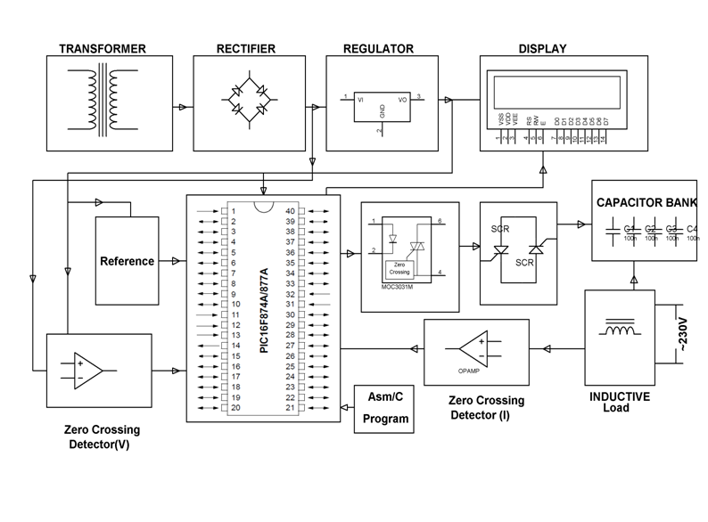

**HARDWARE REQUIREMENTS:**

PIC series Microcontroller, Op-amps, LCD, Shunt capacitors, SCR, opto-isolator, Current Transformer, Inductor, Crystal, Slide Switches, Resistors, Capacitors, Diodes, Transformer, Voltage Regulator, Lamp.

**SOFTWARE REQUIREMENTS:**

HI-TECH PICC Tool suite

Languages: Embedded C or Assembly